**DEPARTMENT OF ELECTRICAL & ELECTRONICS ENGINEERING**

CONSOLIDATED REPORT ON

**EMPLOYERS FEEDBACK ON CURRICULUM**

|  |  |
| --- | --- |
|  | **SRI VENKATESWARA ENGINEERING COLLEGE**  Karakambadi Road, Tirupati - 517 507, A.P.  Accredited by NAAC, Approved by AICTE & Permanently Affiliated to JNTUA  Recognized under section 2(f) & 12 (B) of UGC act 1956. |

|  |  |  |  |  |  |  |  |  |
| --- | --- | --- | --- | --- | --- | --- | --- | --- |
| SLNO | Statements | **Excellent-5** | **Very Good-4** | **Good-3** | **Average-2** | **Below Average-1** | **Sum** | **%** |
| 1 | Curriculum provides ability to manage and have leadership qualities | 7 | 2 | 1 |  |  | 46 | 92.00 |
| 2 | Is our curriculum compatible with the industry standards | 8 | 1 | 1 |  |  | 47 | 94.00 |
| 3 | Is the curriculum sufficient to enable student to analyze a given problem and identify the necessary solutions | 9 | 1 | 0 |  |  | 49 | 98.00 |
| 4 | Creative in response to workplace challenges | 6 | 3 | 1 |  |  | 45 | 90.00 |
| 5 | Ability and motivation for social activity | 7 | 1 | 2 |  |  | 45 | 90.00 |
| 6 | Technical Knowledge/ Skill | 8 | 2 | 0 |  |  | 48 | 96.00 |
| 7 | Overall impression about their performance | 9 | 1 | 0 |  |  | 49 | 98.00 |

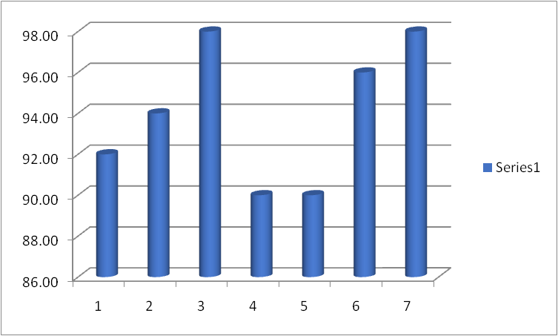

**HOD**